Interpretability-Aware Transformer based Deep Learning Framework for Intelligent Android Malware Detection and Classification
Abstract
With the rapid development of Android malware, which provides harmful impacts to smartphone users, such as credentials theft and resource abuse, it has become one of the most significant concepts in cybersecurity. In recent days, malware writers leverage Artificial Intelligence (AI)-driven malware attack approach to avoid the recognition of malicious activity. Thus, traditional malware detection approaches are struggling to recognize malware versions, which remains a crucial challenge. Nevertheless, the deep learning (DL) techniques are employed for efficient Android malware detection in existing approaches at a large scale, but these approaches are lacking in the model’s interpretability by explaining the contribution of every feature in recognition techniques. This paper introduces an Interpretability-Aware Transformer-based Deep Learning Framework for Intelligent Android Malware Detection (IATDL-IAMD) algorithm. A transformer-based classifier with dense feature embedding and multi-head self-attention is first developed as a baseline to efficiently capture complex relationships among high-dimensional malware features. To address the interpretability limitations of the deep learning approach, SHAP-based explainability is integrated into the proposed framework as a feature selection approach. This integration enables both global and local interpretation of predictions by quantifying feature contributions and mapping malware behavioral patterns. This combination of deep representation learning and interpretability-aware analysis is expected to improve trust and practical usability of the detection system. Comprehenisve experimental outcomes demonstrate the superiority of the proposed approach with maximum accuracy of 96.23% and 98.45% under CICMalDroid 2020 and AndroMD datasets, across various evaluation metrics, confirming its effectiveness in accomplishing robust and interpretable Android malware detection.
Keywords: Malware Detection; Application Programming Interface; Deep Learning; Transformer; Multi-Head Self-Attention; Explainable Artificial Intelligence
1. Introduction
The Android Operating System (OS) has achieved notable popularity with a user base that exceeds a billion individuals ranging more than 190 countries. Initially, Android surpassed all other mobile OS for dominating the mobile market [1]. In modern times, smartphones offer an innovative function comprising e-banking, social networking, and online shopping. The open-source nature of Android, along with its popularity, invaders for developing malware that steals or destroys personal data saved on mobile gadgets by fulfilling their malevolent purposes [2]. Alarming statistics suggest that there are over 4.18 million malevolent applications in the Android sector. The android malwares are developed into a terrific attack on organizations, individuals, and government entities [3]. Although conventional antivirus outcomes are endeavored to combat these malevolent Android applications, its efficacy diminishes against intensifying Android malware. Traditional approaches rely on signatures, although effective for recognizing attacks, often demonstrate insufficient ability to detect innovative, polymorphic, or unidentified malware [4]. To develop new malware versions, cybercriminals misuse software and system vulnerabilities at an alarming rate. This varying and dynamic attack environment requires cutting-edge, changeable, and strong defense modules [5]. Classical models for malware identification mainly relied on heuristic and signature-based strategies. Signature-based modules are effective in identifying attacks, but face complexities in identifying new or diverse malware as they rely on a pre-existing repository of identified malware signatures [6].
Machine Learning (ML) offers the proficiency for recognizing pre-existing malware through the procedure for detecting anomalies and patterns in datasets. Deep Learning (DL) and ML techniques are leveraged for intensifying the predictive outcomes and efficacy of malware identification [7]. DL and ML models fall under the umbrella of artificial intelligence (AI), which offers strong functionality for the investigation of complex datasets. DL and ML systems are employed in numerous areas that include handwritten digit identification, intrusion detection, cyber security, depression detection, object detection, and disease detection in several instances [8]. Nevertheless, the efficiency of ML techniques is substantially impacted by the preprocessing step that is performed on the data. One of the vital challenges in malware recognition exists in the higher dimension of the features [9]. Advanced malware data consists of hundreds of features, and multiple redundant or irrelevant data results in improved computation overhead and decreased model performance [10]. Feature selection (FS) is an essential preprocessing stage that intends to diminish dimensions and retain only the most informative aspects. Detecting a proper set of features is a vital prerequisite to the objective of acquiring sufficient insight from data. Existing analyses have exhibited that the predictive capability of DL methodologies is attained through a partial feature subset instead of every aspect [11]. Nevertheless, the majority of FS approaches require explainability when choosing aspects. Although one feature is prioritized over another, few model offers a quantitative data about this selection, making it complex by explaining why certain aspects are chosen or eliminated [12]. Additionally, existing FS models necessitate consumers by offering equivalent parameters or thresholds to initiate execution of the model. Users often struggle to recognize the most suitable parameter or thresholds for a task, frequently engaging in time-consuming and effort-intensive trial and error processes [13].
This paper presents a novel Interpretability-Aware Transformer-based Deep Learning Framework for Intelligent Android Malware Detection (IATDL-IAMD) approach. The IATDL-IAMD system combined as structured pre-processing, attention-based modeling, and SHAP-driven explanation mechanisms to offer malware behavior analysis. The dual-dataset assessment ensures generalizability and highlighting the framework’s potential as a scalable and transparent recognition solution. The core contributions of this article are summarized as follows:
- To establish baseline detection performance utilizing a transformer-based classifier without incorporating explainability mechanisms, serving as a comparative foundation for performance improvement.
- Although transformer framework accomplish strong predictive performance, they inherently work as black-box methods. The novelty of this work lies in the seamless integration of Explainable AI (XAI) methods in a transformer-based malware recognition system, improving interpretability without compromising classification result.
- SHAP quantifies each feature’s contribution to the final solution and exploits the feature importance mapping to enhance the classification results. The signifincat features identified by the SHAP are fed into the classifier for enhanced Android malware detection.
- Experimental validation on CICMalDroid 2020 and AndroMD datasets confirms the effectiveness and superiority of the proposed method under various performance metrics.
2. Review of Existing Studies
This section offers a comprehensive review of existing studies on Android malware detection and classification using DL techniques. In [14], DL-AMDet, a DL methodology, is recommended for identifying Android malware apps relies on their dynamic and static aspects. DL-AMDet comprises dual major recognition approaches, primarily employing CNN-based models for identifying malware leveraging static investigations. The deep autoencoders are employed for detecting anomalies and malware based on dynamic inspections. Tian et al. [15] propose GRED, an android malware recognition approach that employs GNN for accurately recognizing malevolent behavior, while improving both interpretability and robustness. GRED enhances an android function call graph, acquires structural and semantic APIs, and employs a Top-K-based GNN module for effectual malware recognition. Furthermore, it provides a multi-perspective examination to assist an in-depth understanding of recognition outcomes. Kauser and Anu [16] present a hybrid DL approach (DBN-GRU) that combines DBN for statistical investigation and GRU for a dynamic behavior model by improving recognition efficacy. The method acquires static aspects and dynamic features from Android APKs, allowing a wide-ranging investigation of application behavior.
Maray et al. [17] propose an IPR-EODL methodology for android malware recognition. The goal of the IPR-EODL model is to classify and recognize Android malware in such a manner. Additionally, the CA-LSTM approach for the identification of Android malware. In addition, the IPR-EODL methodology leverages the EO for choosing parameters. Rashid et al. [18] examined a DL-based module for Android malware recognition, which tackles crucial restrictions in present models, specifically to manage obfuscation and extensibility with faster mobile app development cycles. Different prior models, the projected approach incorporates a multi-dimensional analysis of Android permissions and API calls, allowing strong representation with revoked engineering restrictions. In [19], a multi-feature hybrid malware identification and classification HGDetector model has been proposed; this model offers an extensive depiction of software behavior. Next, these aspects are fused and transformed to vectorized depiction by utilizing graph-embedded approaches. Eventually, the presented HGDetector model, integrated with diverse approaches are utilized to test the effectiveness of malware recognition and classification.
Tang et al. [20] suggest a hybrid heterogeneous graph-based Android malware recognition approach through multi-evidence similarity fusion called HHGDroid. The function call graph created by static investigation and event graph attained by dynamic analysis were interconnected by an extensive resemblance of many evidences like permissions, time frequency, and semantics, eventually developing the hybrid heterogeneous graph with many heterogeneous edges and nodes. Cam et al. [21] suggest uitMalDeQ, a Windows malware identification module that incorporates DQL with XAI by offering both competitive categorization outcomes and explainable decision-making. The major frameworks train the DQL agent on labeled instances and calculate it against sturdy baselines utilizing standard measures. SHAP incorporation helps two objectives: assessing feature aids for intelligibility and FS for strengthening efficacy. Table 1 displays the existing related studies on android malware detection.
Table 1 Literature review of related works
Authors | Research Aim | Approaches | Outcomes | Research Gaps
Nasser et al. [14] | To design framework for effective Android malware detection using static and dynamic features. | CNN, Bi-LSTM, and a Deep autoencoder | Accuracy of 99.935 %. | Existing methods often lack effective static-dynamic integration and performance.
Tian et al. [15] | To design an effective and explainable Android malware detection framework that enhances robustness and improves detection performance. | GCN model | Attains a better performance. | The mobile malware detection methods often lack robustness and explainability in identifying malicious behavior.
Kauser and Anu [16] | To design a hybrid DL model for effective Android malware detection with improved accuracy and efficiency. | DBN and GRU approaches | Accuracy of 98.7%. | Existing detection methods struggle with advanced threats and feature integration.
Maray et al. [17] | To design a high-performance intelligent model for effective android malware identification with improved detection capability and efficiency. | CA-LSTM and EO models | Accuracy of 99.18%. | Current methods face optimization limits, reducing overall detection effectiveness.
Rashid et al. [18] | To develop a DL-based Android malware detection framework with improved robustness, scalability, and explainability. | Machine Learning techniques | Accuracy of 98.2%. | Conventional methods struggle with obfuscation, scalability, and evolving threats.
Feng et al. [19] | To design a hybrid feature-based malware detection model that combines static and dynamic analysis. | Deep Learning approaches | Improve accuracy by 21 % to 26 %. | Single-feature methods often fail to capture complete application behavior.
Tang et al. [20] | To progress hybrid graph-based android malware detection model that effectively integrates static and dynamic features for improved performance. | Graph Transformer framework | F1-score of 97.87%. | Existing hybrid methods struggle to model static-dynamic feature relationships.
Cam et al. [21] | To develop an explainable learning framework for accurate and interpretable Windows malware classification. | Deep Q-Learning and Explainable Artificial Intelligence approaches | Accuracy to 98.73%. | Current models lack adaptability and explainability against evolving threats.

2.1. Research Gaps
Although existing studies have shown strong progress in Android malware detection using deep learning and graph-based approaches several limitations still exist. Many works such as Nasser et al. [14] and Rashid et al. [18] mainly concentrated on enhancing classification accuracy using deep neural networks, but they do not overcome the explainability of the decision-making process, which makes it challenging to understand feature contributions. Similarly, Tian et al. [15] and Tang et al. [20] employed graph neural networks and hybrid graph-based approaches for malware detection, but these methods are computationally complex and still lack clear explanation of model predictions for practical cybersecurity use. Besides, Cam et al. [21] integrated DL with explainable AI techniques, but the focus is limited to post-hoc explanation instead of integrating interpretability within the model architecture. Thus, there is a need for a better performing framework, and this study focuses on designing a transformer-based malware detection system that achieves high classification performance with built-in interpretability for robust Android malware analysis.
3. Model Development Approach
The proposed IATDL-IAMD framework contributes toward building trustworthy AI-driven cybersecurity systems by addressing the dual challenge of accuracy and interpretability in Android malware detection. Fig. 1 represents the entire flow of the presented IATDL-IAMD approach. First, a structured preprocessing pipeline is designed, including data cleaning, missing value handling, label encoding, feature scaling, and train-test splitting to generate optimized feature representations. Second, a transformer-based classifier with dense feature embedding and multi-head self-attention is developed to effectively capture complex relationships among high-dimensional malware features. Third, SHAP-based explainability is incorporated to quantify feature contributions and provide both global and local interpretations of model predictions. Fourth, the integration of SHAP with the Transformer architecture enhances transparency, enabling meaningful malware behavior analysis and improving trustworthiness in Android malware recognition.
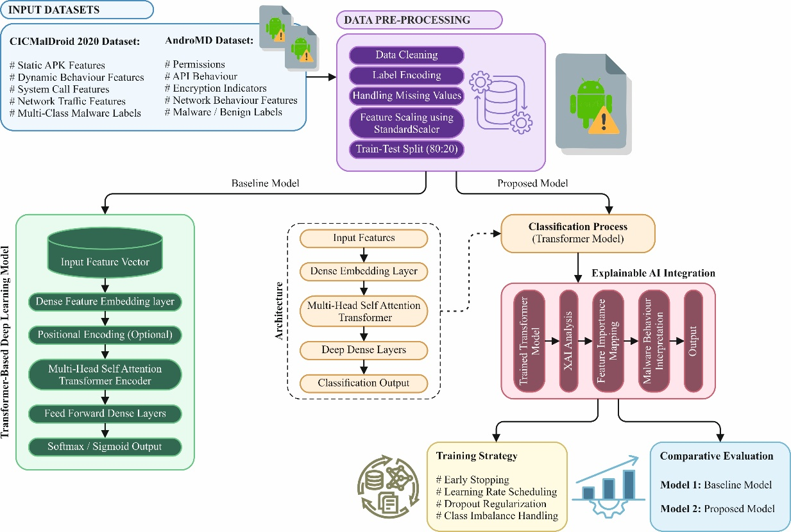
Fig. 1. Overall flow of IATDL-IAMD framework
3.1. Data Used
The proposed model can be trained and evaluated using two benchmark datasets, namely the CICMalDroid 2020 Dataset [22] and the AndroMD Dataset [23], to ensure robust performance and comprehensive analysis across diverse Android malware samples.
CICMalDroid 2020 Dataset: This dataset contains 17,341 Android applications that includes recent samples collected up to 2018. It covers five categories like Adware, Banking malware, SMS malware, Riskware, and Benign, which offers an extensive set of static and dynamic features compared with other publicly available datasets. Fig. 2 illustrates the class distribution.
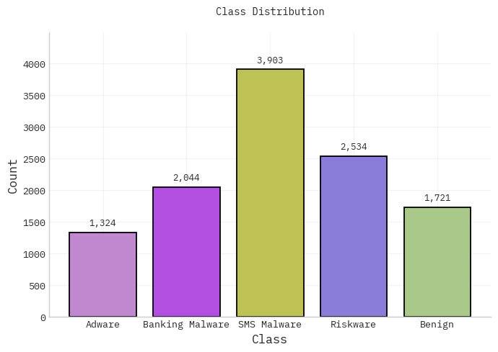
Fig. 2. Class distribution with CICMalDroid data
AndroMD Dataset (Latest): This large-scale Android malware dataset comprises 600,298 applications that includes both benign and malicious instances gathered from many sources among 2010 and 2023. It comprises 3 feature subsets—KeyCount, ZeroOne, and MNF derived by automated decompilation and static analysis. The dataset is intended to support ML-based malware detection and real-time classification tasks. Fig. 3 illustrates the class distribution.
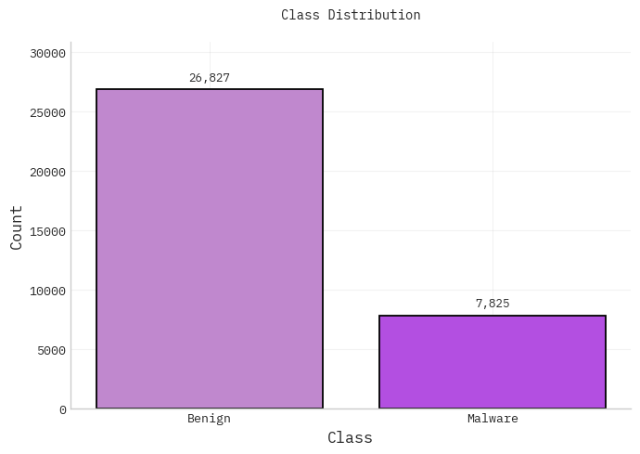
Fig. 3. Class distribution with AndroMD data.
3.2. Data Preparation and Preprocessing
Initially, comprehensive preprocessing is performed to ensure high-quality feature representation.
Data Cleansing: Data cleansing is a vital stage that ensures the quality of data [24]. It entails removing or rectifying incomplete data, resolves discrepancy, and normalizing data into a constant format. The consequence of this step is that any dataset including erroneous, incomplete, unrelated, or inaccurate data has been present ambiguity in the explanation of analytical outcomes. Data cleansing becomes more crucial as the size of the dataset amplifies, owing to difficult concerns like duplicate data, missing data, or incompatible data formats.
Label Encoding: Label Encoding is carried out to convert categorical variables into numerical form, allowing their effective usage in ML approaches. Since most ML techniques necessitate numerical input, categorical labels were systematically transformed to integer depictions. Every unique class is allocated a diverse numerical value while maintaining data consistency. It assures computational balance without modifying the inherent data structure. In detail, the label encoding is well-suited for ordinal categorical variables but instinctive ranking exists, thus preserving meaningful relations among classes in model training.
Missing Value Handling: Handling missing values is a vital preprocessing stage by assuring sturdiness of the model and the trustworthiness of the data. Primarily, missing entries were recognized by systematic data inspection models. Based on the nature and distribution of missing data, proper imputation approaches are employed. Usually, the numerical attributes are managed by utilizing statistical imputation models like median or mean substitution, whereas categorical features are addressed by utilizing mode imputation. In such instances, here missingness can substantially influence performance of model, sophisticated approaches like forward or backward filling or model-based imputation are leveraged.
Data Normalization: Normalization is applied to standardize data and improve its adaptability. Nevertheless, normalization is vital to diminish the ambiguity in data. Normalization is carried out to lessen the influence of comprehensive feature values on certain measurements by utilizing feature scaling. Feature scaling with standardization or other scaling processes involves modifying the data values and assists in preprocessing. It is used to generate the data more attainable for analysis.
The feature scaling technique leveraged in this study is $Z$‐score normalization, commonly referred to as the Standard Scaler. This model is a statistical tool that assumes the data follows a normal distribution and converts it to ensure the data is centered at $0$, with a SD of $1$. This process involves calculating every data element’s average and SD by excluding any data element that holds disproportionately huge values relevant to others.
$$Z_{scaled}=\frac{\left(x-μ\right)}{σ} (1)$$
Data Splitting: Data splitting refers to dividing data into dual subsections with the goal of training and testing methods independently. At this stage, the data is partitioned into two parts, utilizing 70:30. The primary portion is employed to train the model, whereas the secondary part is leveraged to test the prediction capability of the model. Furthermore, it is desirable to have the training set size as large as possible to lessen overfitting.
3.3. Baseline Model
In this section, a transformer model leveraging multi-head self-attention is designed to learn complex malware behavior patterns. The proposed model employs the strength of the transformer framework for Android malware detection [25]. This framework also integrates cutting-edge mechanisms, enabling the method to acquire longer‐range dependency and contextual relations in data. It is suitable for a multi‐class classification process, improving its capability to properly distinguish several threats. Fig. 4 illustrates the general infrastructure of the transformer model.
Multi‐Head Attention (MHA): MHA enables the method to concentrate on numerous portions of the input order at a time. This method acquires several relations in the series utilizing many attention heads or modules, comprising longer‐term dependence or positional relevancy. This transformer module improves its capability to understand intricate aspects of data.
$$Attention\left(Q,K,V\right)=softmax\left(\frac{QK^{T}}{\sqrt{d_{k}}}\right)y (2)$$
The attention module is assessed to carry out weighted addition of value vectors $(V)$. This weighted addition has been originated utilizing the resemblance of query and key vectors. The calculation for single‐head attention is specified in Eq. (2). Now, $K,$ $V,$ $Q$ imply the key, value, and query matrices created by input $X$, whereas $d$ and $k$ indicate the dimension of key vector, leveraged to standardize the dot product.
$$MultiHead\left(X\right)=Concar\left(head_{1}, head_{2}, …, head_{h}\right)W_{O} (3)$$
In MHS, the $head$ generates in parallel and concatenates the modules; $h$ depicts the attention head counts, whereas $W_{O}$ implies the projection matrix. It helps to learn diverse input relations, one of which contributes to enhancing its representation proficiency.
Feed‐Forward Network: The dual-layered dense network is employed independently for every position in order and functions the feed‐forward network (FFN). Non‐linearity has been presented to enhance the feature representation obtained from the attention module.
$$FFN\left(x\right)=RelU\left(xW_{1}+b_{1}\right)W_{2}+b_{2} (4)$$
Now, $b_{1}$ and $b_{2}$ refers to biased terms; ReLU indicates rectified linear unit activation function; $W_{1}$ and $W_{2}$ denotes weighted matrices. The FFN procedures the attention outcomes and adds depth by allowing the method to effectively acquire intricate aspects.
Residual Connection and Layer Normalization (LN): The vital elements include LN and residual connections, which help to stabilize and strengthen the training procedure. The residual connection adds input to the outcome of the layer, ensuring that important information from the preceding layer has been preserved.
$$Output_{LσyerNorm1}=LayerNorm\left(X+MultiHead\left(X\right)\right) (5)$$
$$Output_{LσyerNorm2}=LayerNorm(Output_{LσyerNorm1}+FFN\left(Output_{LayerNorm1}\right) (6)$$
The outcomes are standardized utilizing LN that assures constant training. Normalization assures that the data values take 0 mean and unit variance. Residual connections avoid the issue of vanishing gradient and smooth the flow of gradient, while LN accelerates convergence and preserves the training steadiness.
Global Average Pooling (GAP): GAP is a dimension reduction method that integrates the data order by calculating an average value at every aspect. It converts the data sequence into a fixed‐length depiction that is employed for categorization.
$$GAP\left(X\right)=\frac{1}{n}\sum_{i=1}^{n}{X_{i}} (7)$$
However, $X_{i}$ implies the vectorized feature at position $i$ and $n$ refers to length of the sequence. GAP diminishes computation overhead whereas retain essential data. It serves as a link among order data and dense layer for classification process.
The dense layers can be employed to form the classification head of model. They convert the collected aspects to an outcome probability. The primary dense layer presents non‐linearity, whereas the last dense state generates class probability utilizing the softmax function. The operators are specified.
Hidden Layer:
$$H=ReLU\left(XW_{h}+b_{h}\right) (8)$$
Output Layer:
$$Y=SoftMax\left(HW_{y}+b_{y}\right) (9)$$
Here, $b_{h}$ and $b_{y}$ implies biased terms; $W_{h}$ and $W_{y}$ refers to weighted matrix. This softmax function assures that the outcome forms a valid probability distribution across the entire classes. Dense layers method every feature to generate predictions that associate with real‐world scenarios.
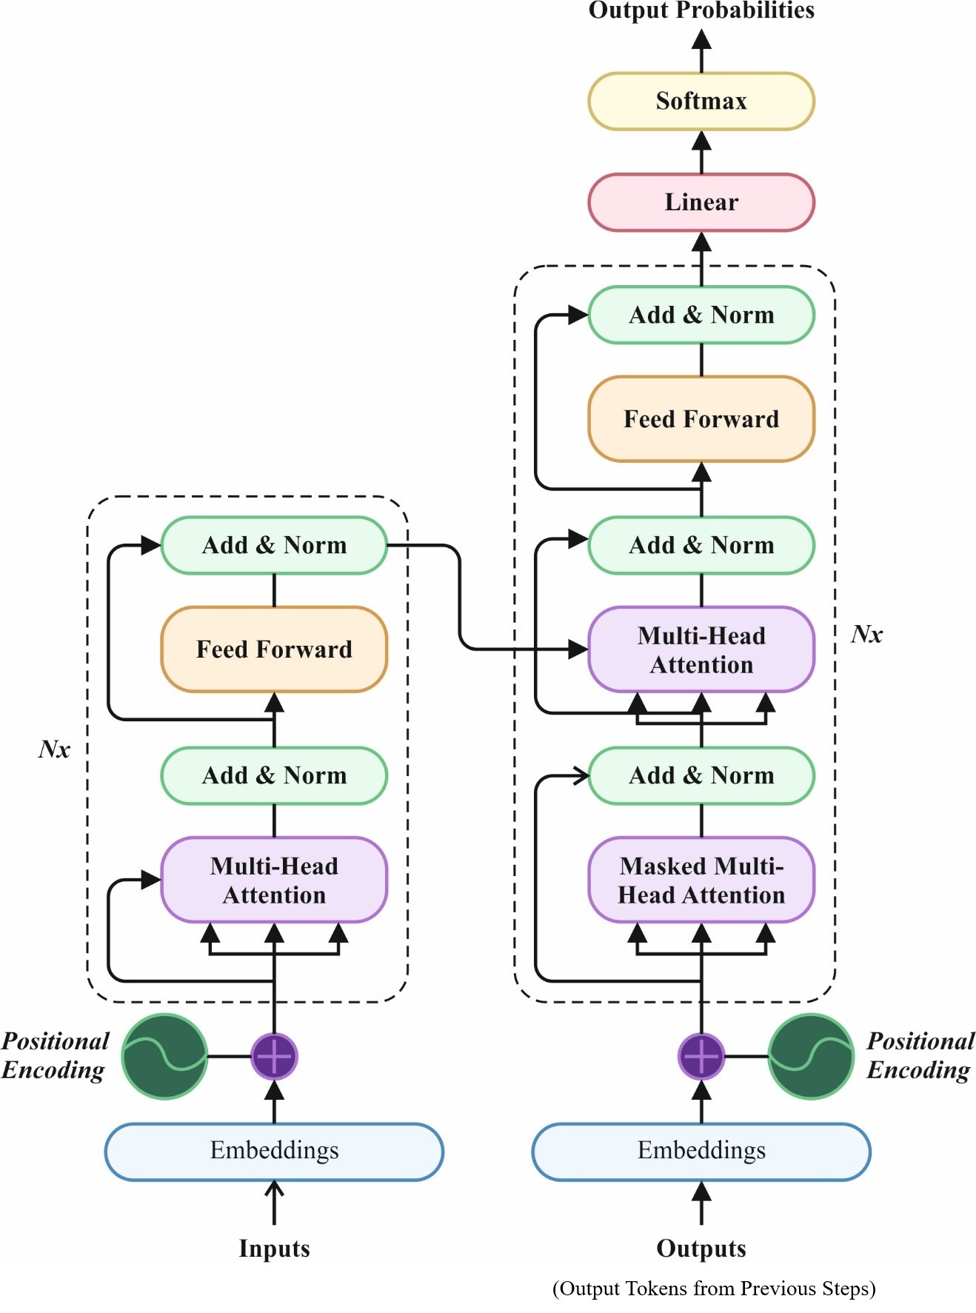
Fig. 4. Architecture of transformer model

3.4. Explainable Transformer Model
To enhance the interpretability of the transformer-based framework by integrating SHAP for transparent and feature-level explanation of predictions.
SHAP Value: This framework for a proposed transformer‐based android malware detection by utilizing SHAP values for model interpretability [26]. These values play a critical role in determining the contribution of every feature to model predictions. The major notion entails calculating the incremental SHAP value integrated with the method, thus supporting an understanding of feature consequence across SHAP values. It is driven by game theory; the SHAP value calculates individual donations in cooperative scenarios. This approach is well-suited for explaining predictions with ML modules, as the Shapley value measures the average control of each aspect on the predictions through each possible integration:
$$ϕ_{i}\left(f,x^{'}\right)=\sum_{z^{'}\{x_{1}^{'},…x_{n}^{'}\}\{x_{i}^{'}\}}{\frac{\left|z^{'}\right|!\left(M-\left|z^{'}\right|-1\right)!}{M!}}*\left[f\left(z^{'}∪x_{i}^{'}\right)-f\left(z^{'}\right)\right] (10)$$
Where, $x_{i}^{'}$ implies $i_{th}$ feature in vector $χ^{'};$ $χ^{'}=\{x_{1}^{'}, …,x_{n}^{'}\}$ indicates the feature vector of samples to be interpreted; $z^{'}$ represents a features subset; $M$ denotes the feature counts; $f(z^{'})$ implies the expected value of $z^{'}$. While $f(z^{'})$ is assessed, the $i^{th}$ feature has been masked, and subsequently, the random instance or value of $i^{th}$ feature acquired and replicated the $i_{th}$ features. Now, the $ϕ_{i}(f,x^{'})$ assess the weighted average of marginal contributions variable $x_{i}^{'}$ through every probable subset $z^{'}$.
The calculation of SHAP value is reasonable for each feature, enabling a global evaluation compared to the SHAP values of features through numerous instances. SHAP is an additive explanatory method that derives from the concept of Shapley value. It allocates a SHAP value to every aspect for each instance, equivalent to the model calculation for those instances. If specify the $i_{th}$ instance by $X_{i}$, the $j_{th}$ feature of these instances $χ_{ij}$, the predicted value, for instance $Y_{i}$, and the baseline value of model is $Y_{base}$, the SHAP value follows the specified equation:
$$Y_{i}=Y_{base}+f\left(χ_{i1}\right)+f\left(χ_{i2}\right)+f\left(χ_{i3}\right)+f\left(χ_{i4}\right)+⋯+f\left(χ_{ik}\right) (11)$$
The SHAP value is depicted as $(χ_{ik})$, depicts the contribution of $k_{th}$ feature in $i_{th}$ instance, $χ_{ik}$ to final prediction of model $Y_{j}$. The positive SHAP value, $f(χ_{ik})>0,$ specifies aspect that comprises valuable influences on predicted solutions. On the other hand, a negative SHAP value shows detrimental impacts, lessening the expected solutions. The major benefit of SHAP value is capable to acquire every instance, exhibiting negative and positive correlations. Eventually, choose the optimum feature subset that connects to connection from the pre‐ranked aspects, this assisting the task of FS.
The architecture of Model Interpretability: The interpretability component of the proposed Transformer and SHAP framework operates at both local and global levels.
Local interpretation entails calculating and visually depicting the input of every feature to the expected result for individual samples.
$$y_{i}=y_{base}+f\left(x_{i1}\right)+f\left(x_{i2}\right)+f\left(x_{i3}\right)+f\left(x_{i4}\right)+⋯+f\left(x_{ik}\right) (12)$$
Here, $y_{base}$ depicts the average of calculated values for every instance; $y_{i}$ implies the value predicted, for instance $χ_{i}$.
For the global explanation, the primary stage entails calculating a matrix but the value of SHAP for aspects were arranged, allocating every sample to row and every feature to column. In classical global interpretation, the influence of feature $j$ has been determined by accumulating the average Shapley rate of aspect $j$ under every sample. Afterwards, the SHAP values were organized in descending order by establishing the consequence of features in the model.
$$f\left(x_{j}\right)=\sum_{i=1}^{M}{f}\left(x_{ij}\right) (13)$$
3.5. Model Interpretability Module
The proposed framework integrates SHAP to improve the interpretability of transformer-based malware identification system. Once the transformer framework is leveraged, SHAP is used to calculate the contribution score of features that measure the control of every input data on the final outcome. This procedure allows the generation of both global interpretations that offer an entire ranking feature over the dataset, and local explanations to explain individual decisions at the level of the instance. Furthermore, attention heatmaps are generated to visually depict feature impacts and interaction modules. By systematically explaining malware behavior patterns over these explainability outcomes, this model substantially increases reliability, transparency, and understanding for cybersecurity experts.
3.6. Performance Metrics
Performance measures are vital to calculate how effectually DL approach performs, as every metric reflects diverse aspects of performance. Here, standard classification metrics are employed to calculate and compare the model performances.
Accuracy: It is used to calculate the ratio of properly predicted instances to overall observations.
$$Accuracy=\frac{TP+TN}{TP+TN+FP+FN} (14)$$
Precision: It refers that how many of the chosen data are truly relevant, meaning the percentage of properly predicted positive cases. It is measured as the percentage of TP to the sum of TP and FP.
$$Precision=\frac{TP}{TP+FP} (15)$$
Sensitivity: It indicates that, overall, actual positive samples are correctly identified. It determines the percentage of TP to the sum of TP and FN.
$$Sensitivity=\frac{TP}{TP+FN} (16)$$
Specificity: Calculates the percentage of actual negative instances properly recognized by the method.
$$Specificity=\frac{TN}{TN+FP} (17)$$
G-Measure: It determines a clustering model through metrics of its purity and accounts. The harmonic mean of recall and accuracy balancing for FP and TP rates. Now, 1 value specifies perfect clustering, while 0 depicts arbitrary clustering.
$$G-Measure = \sqrt{\left(precision× recall\right)} (18)$$
4. Experimental Results and Analysis
The performance assessment of the IATDL-IAMD approach is inspected on dual datasets comprises CICMalDroid 2020 Dataset and AndroMD Dataset.
4.1. Result Analysis on CICMalDroid 2020 Dataset
Fig. 5 shows the confusion matrices created by the IATDL-IAMD approach on the Train/Test using CICMalDroid data without feature selection (FS). The solution indicates that the IATDL-IAMD model has effective recognition of every class label.
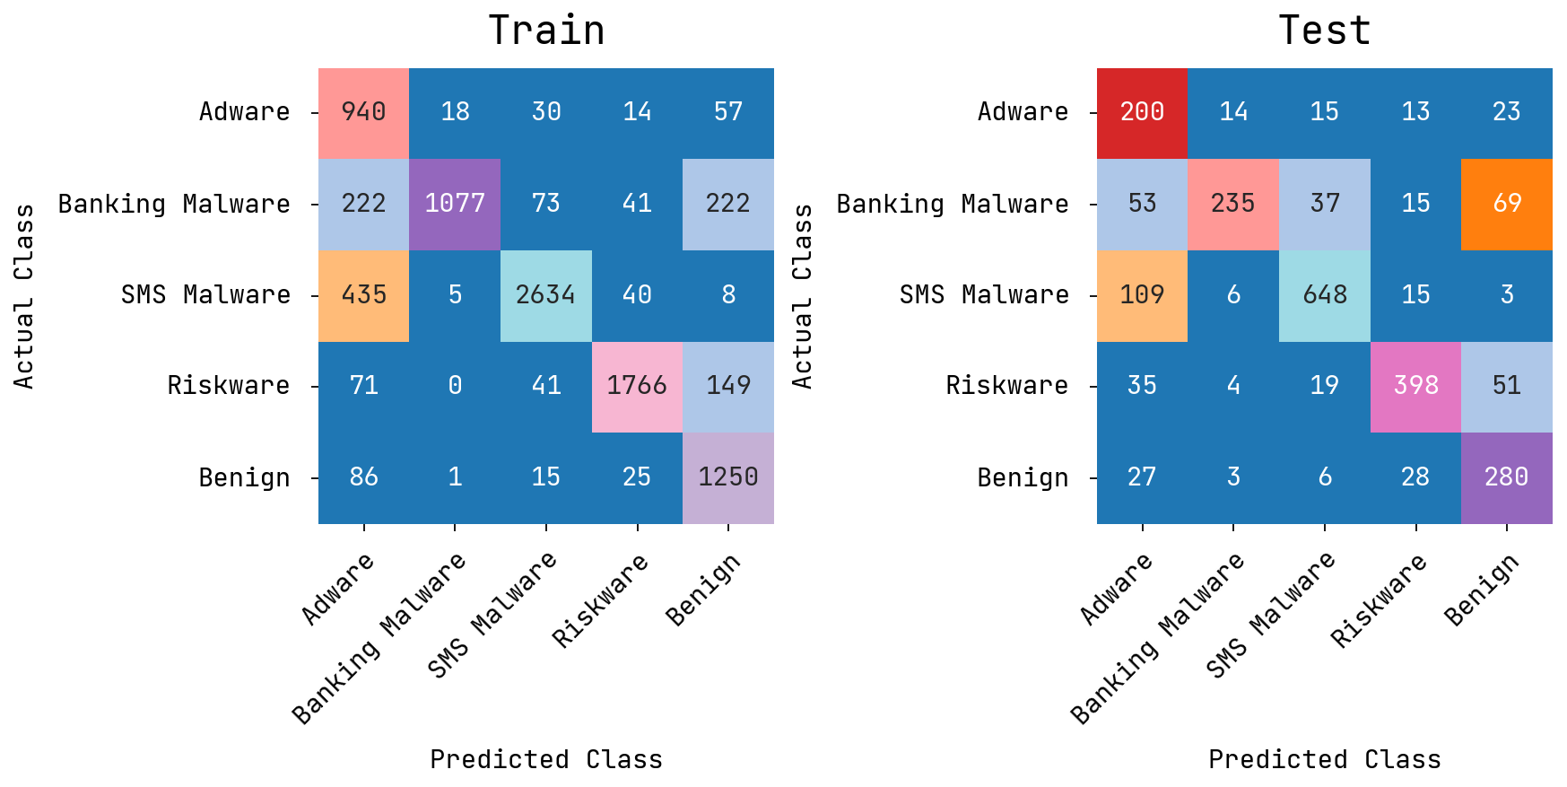
Fig. 5. Confusion matrices of the IATDL-IAMD method without FS under CICMalDroid data
Table 2 represents the training and testing outcomes of IATDL-IAMD technique using CICMalDroid data without FS under several metrics. In training set, the proposed IATDL-IAMD approach offers an average value with $accur_{y}$ of 93.26%, $preci_{n}$ of 82.70%, $sen{si}_{y}$ of 83.38%, $spe{ci}_{y}$ of 95.97%, and $G_{measure}$ of 78.35%, correspondingly. Likewise, in testing set, the proposed IATDL-IAMD approach offers an average value with $accur_{y}$ of 90.55%, $preci_{n}$ of 75.37%, $sen{si}_{y}$ of 75.16%, $spe{ci}_{y}$ of 94.23%, and $G_{measure}$ of 68.91%, respectively.
Table 2 Train/Test set results of IATDL-IAMD method on CICMalDroid data without FS
Metrics | Training Set | Testing Set
Accuracy | 93.26 | 90.55
Precision | 82.70 | 75.37
Sensitivity | 83.38 | 75.16
Specificity | 95.97 | 94.23
G-Measure | 78.35 | 68.91
Fig. 6 demonstrates the global and local feature significance utilizing SHAP analysis under CICMalDroid data . The left panel exhibits the most significant aspects relies on their mean SHAP values, depicting their entire contribution to prediction of model. The right panel offers the local explanation, here every point shows the influence of individual values on prediction outcome. The color gradient depicts lower to higher feature values, emphasizing how feature magnitude impacts the decision-making process of model.
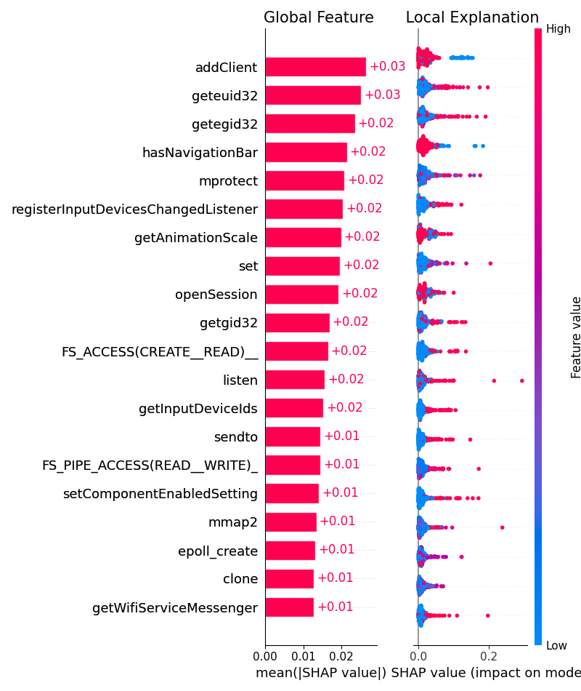
Fig. 6. SHAP analysis under CICMalDroid data
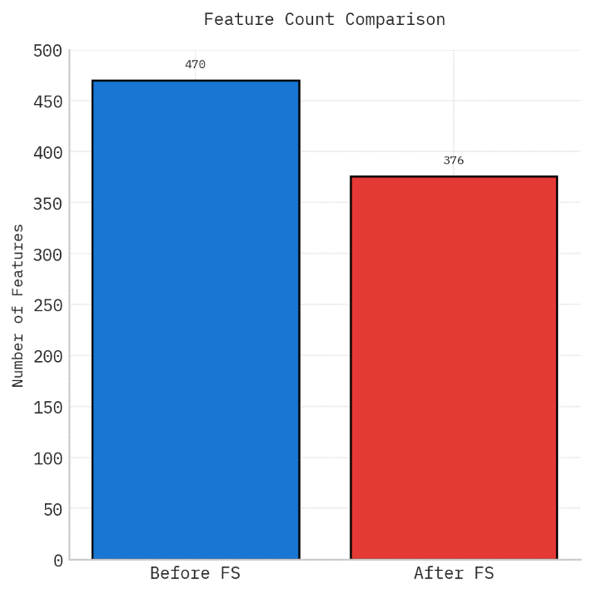
Fig. 7. Before FS and After FS under CICMalDroid data
Fig. 7 depicts the results of the proposed model before FS and after FS on the applied CICMalDroid data. The figure highlighted that the proposed model significantly reduced the feature subset by selecting 376 features.
Fig. 8 indicates the confusion matrices formed by the IATDL-IAMD model on the Train/Test using CICMalDroid data with FS. The solution requires that the IATDL-IAMD approach has effectual recognition of every class labels.
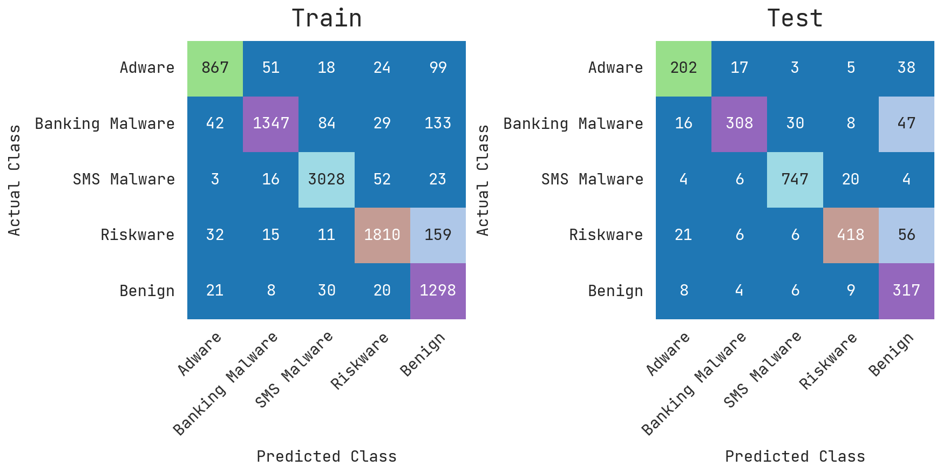
Fig. 8. Confusion matrices of the IATDL-IAMD method with FS under CICMalDroid data
Table 3 denotes the training and testing solutions of IATDL-IAMD approach using CICMalDroid data with FS under several metrics. In training set, the proposed IATDL-IAMD approach offers an average value with $accur_{y}$ of 96.23%, $preci_{n}$ of 89.69%, $sen{si}_{y}$ of 88.96%, $spe{ci}_{y}$ of 97.65%, and $G_{measure}$ of 86.89%, respectively. At the same time, in testing set, the proposed IATDL-IAMD methodology offers an average value with $accur_{y}$ of 94.55%, $preci_{n}$ of 84.92%, $sen{si}_{y}$ of 84.36%, $spe{ci}_{y}$ of 96.64%, and $G_{measure}$ of 81.12%, respectively.
Table 3 Train/Test set results of the IATDL-IAMD method on CICMalDroid data with FS
Metrics | Training Set | Testing Set
Accuracy | 96.23 | 94.55
Precision | 89.69 | 84.92
Sensitivity | 88.96 | 84.36
Specificity | 97.65 | 96.64
G-Measure | 86.89 | 81.12
Fig. 9 illustrates the PR/ROC curves of the IATDL-IAMD model on training and testing stages using CICMalDroid data. Figs. 9a and 9c denote the PR curve of the IATDL-IAMD approach. The outcome specified that the IATDL-IAMD approach leads to amplifying the PR values. Additionally, it is distinct that the IATDL-IAMD model achieves greater PR values on every class labels. Eventually, Figs. 9b and 9d exemplifies the ROC examination of the IATDL-IAMD approach. The figure defined that the IATDL-IAMD system results an enhanced ROC value. Moreover, it is noticeable that the IATDL-IAMD algorithm can expand upgraded ROC values on every class labels.
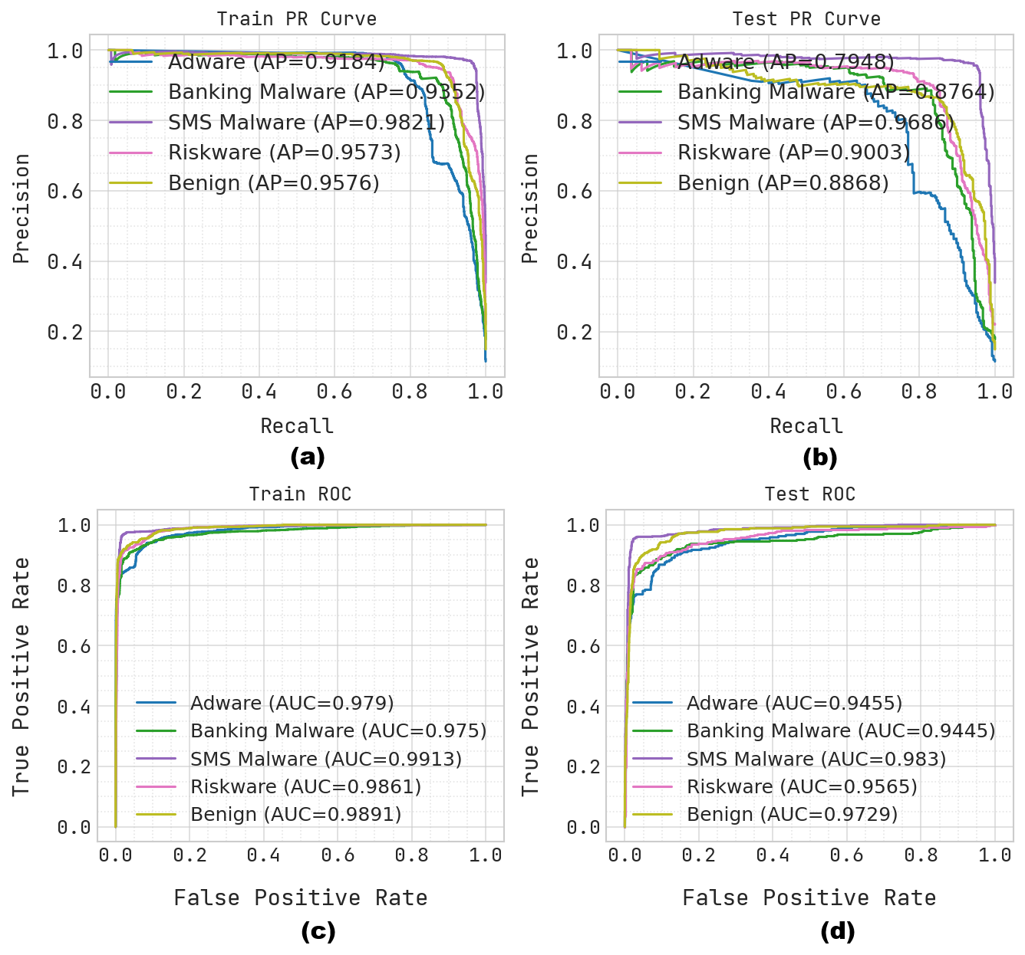
Fig. 9. PR/ROC curve of the IATDL-IAMD method with (a, c) Training and (b, d) Testing phases on on CICMalDroid data
Fig. 10 compare the training and validation outcomes of the Base Model and the XAI Model through epoch counts. In the Base Model, accuracy increases progressively whereas validation loss differs, depicting lessen generalization. Conversely, the XAI Model establishes more steady training and validation accuracy with smoothen loss convergence. The decreased fluctuations and enhanced constancy recommend that the XAI Model accomplishes greater steadiness and generalization outcomes.
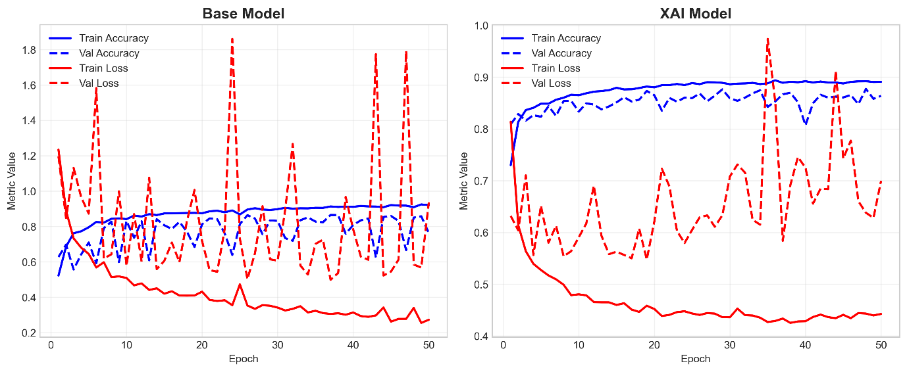
Fig. 10. Accuracy and Loss Graphs of Base and XAI models on CICMalDroid dataset
The comparison outcomes of the IATDL-IAMD methodology with existing models on the CICMalDroid data with numerous evaluation metrics are depicted in Table 4 and Fig. 11. The experimental outcomes specify that the IATDL-IAMD methodology exceeds the existing models. The outcome emphasized that the NB approach has proven ineffective outcomes with $accur_{y}$ of 88.00%, $preci_{n}$ of 91.89%, $sen{si}_{y}$ of 90.26%, and $spe{ci}_{y}$ of 90.08%, respectively. In the meantime, SVR (RBF), SVM, RF, Drebin and MaMaDroid techniques are gained closer solutions. Moreover, the IATDL-IAMD (Baseline Model) approach has exhibited considerable outcomes with $acc{ur}_{y}$ of 93.26%, $pre{ci}_{n}$ of 82.70%, $sen{si}_{y}$ of 83.38%, $spe{ci}_{y}$ of 95.97%, and $G_{measure}$ of 78.35% whereas the IATDL-IAMD (Baseline +XAI Model) has attain maximum solution with $accur_{y}$ of 96.23%, $preci_{n}$ of 89.69%, $sen{si}_{y}$ of 88.96%, $spe{ci}_{y}$ of 97.65%, and $G_{measure}$ of 86.89%.
Table 4 Comparison study of the IATDL-IAMD method with existing systems under CICMalDroid data
Models | $Acc{ur}_{y}$ | $Pre{ci}_{n}$ | $$Sen{si}_{y}$$ | $$Spe{ci}_{y}$$ | $$G_{Measure}$$
SVR (RBF) | 95.74 | 94.76 | 98.06 | 96.38 | 77.84
SVM | 92.00 | 90.00 | 93.00 | 91.50 | 74.03
Random Forest | 95.00 | 94.00 | 96.00 | 95.00 | 76.99
Drebin | 94.70 | 94.50 | 97.50 | 93.90 | 74.38
MaMaDroid | 93.70 | 95.20 | 87.20 | 91.00 | 72.49
Naive Bayes | 88.00 | 91.89 | 90.26 | 90.08 | 78.49
IATDL-IAMD (Baseline Model) | 93.26 | 82.70 | 83.38 | 95.97 | 78.35
IATDL-IAMD (Baseline +XAI Model) | 96.23 | 89.69 | 88.96 | 97.65 | 86.89
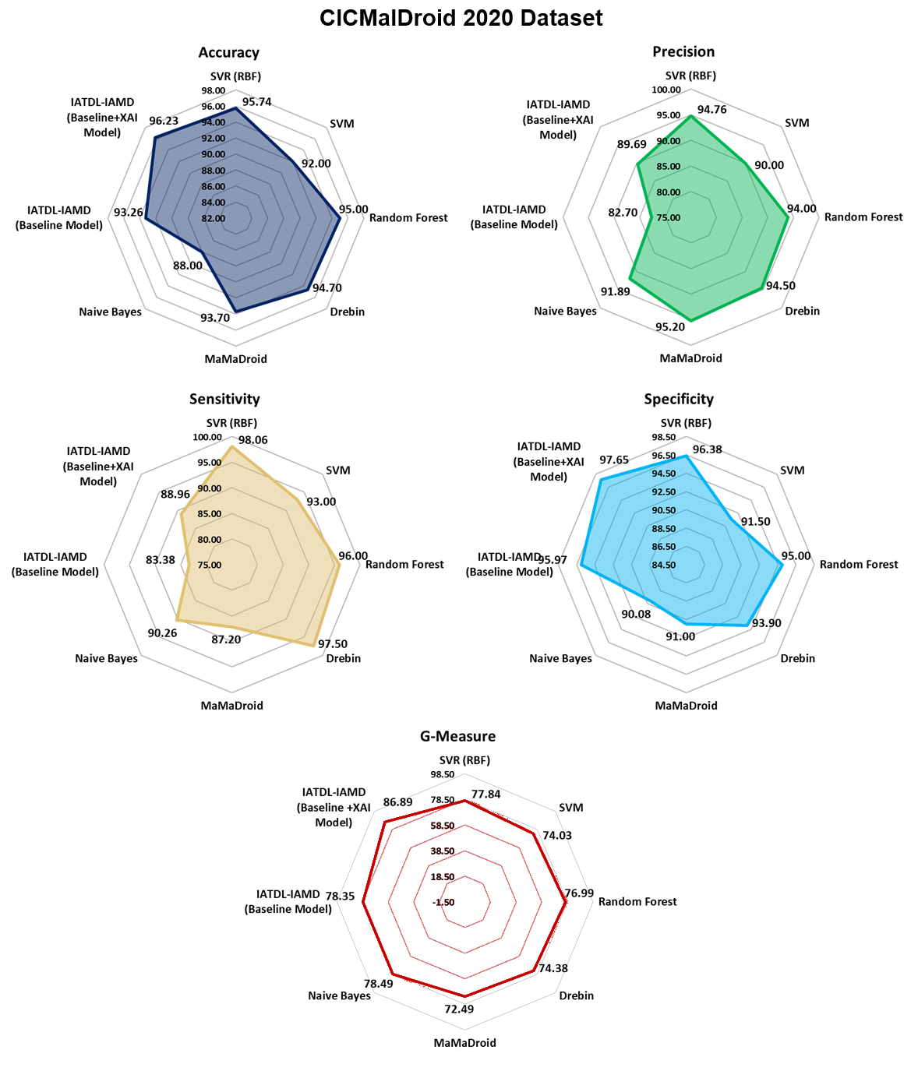
Fig. 11. Comparison result of the IATDL-IAMD method with different measures
4.2. Result Analysis on AndroMD Dataset
Fig. 12 depicts the confusion matrices formed by the IATDL-IAMD approach on the Train/Test using AndroMDdata without FS. The solution designates that the IATDL-IAMD approach have effectual recognition of every classes.
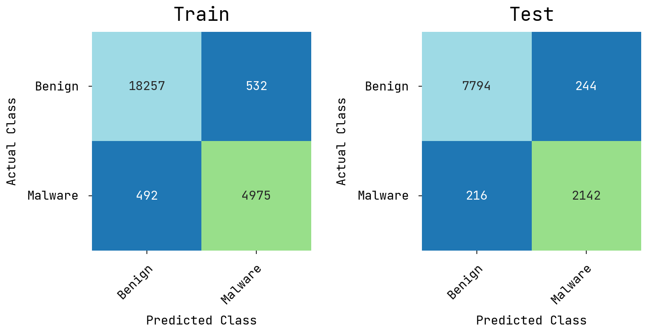
Fig. 12. Confusion matrices of the IATDL-IAMD method without FS under AndroMDdata
Table 5 illustrates the training and testing outcomes of IATDL-IAMD methodology on AndroMD data without FS using numerous metrics. On training set, the proposed IATDL-IAMD approach offers an average result with $accur_{y}$ of 95.78%, $preci_{n}$ of 93.86%, $sen{si}_{y}$ of 94.08%, $spe{ci}_{y}$ of 94.08%, and $G_{measure}$ of 87.94%, respectively. Simultaneously, on testing set, the proposed IATDL-IAMD approach offers an average value with $accur_{y}$ of 95.58%, $preci_{n}$ of 93.54%, $sen{si}_{y}$ of 93.90%, $spe{ci}_{y}$ of 93.90%, and $G_{measure}$ of 87.44%, correspondingly.
Table 5 Train/Test set results of the IATDL-IAMD method on AndroMD data without FS
Metrics | Training Set | Testing Set
Accuracy | 95.78 | 95.58
Precision | 93.86 | 93.54
Sensitivity | 94.08 | 93.90
Specificity | 94.08 | 93.90
G-Measure | 87.94 | 87.44
Fig. 13 demonstrates model interpretability utilizing SHAP analysis under AndroMD data. The left side offers global feature significance; ranking aspects rely on their entire contribution to the model's predictions. The right side exhibits local explanations, depicting how individual values impact certain predictions. Color variation indicates feature magnitude, whereas the horizontal spread determines the direction and resilience of impact.
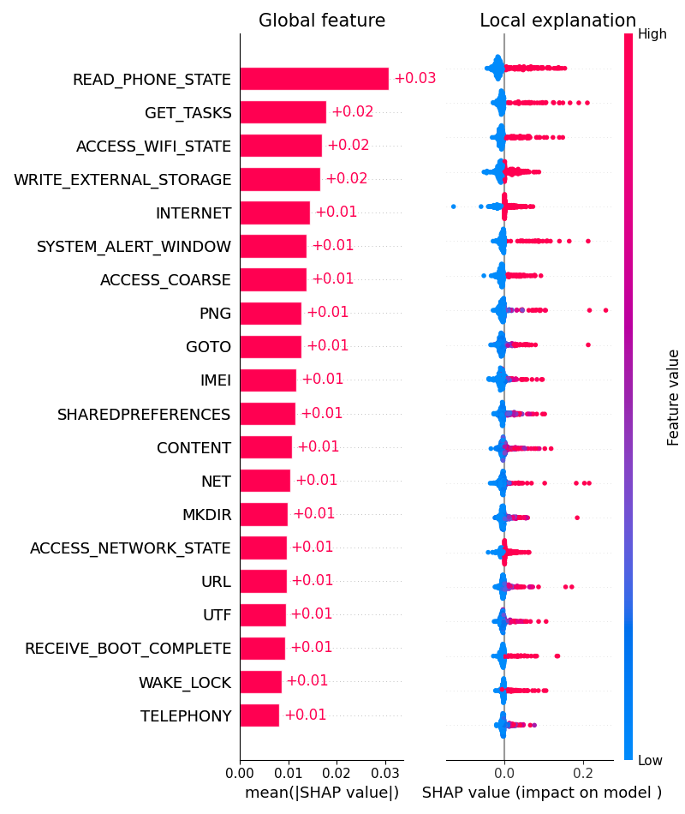
Fig. 13. SHAP value under AndroMD data
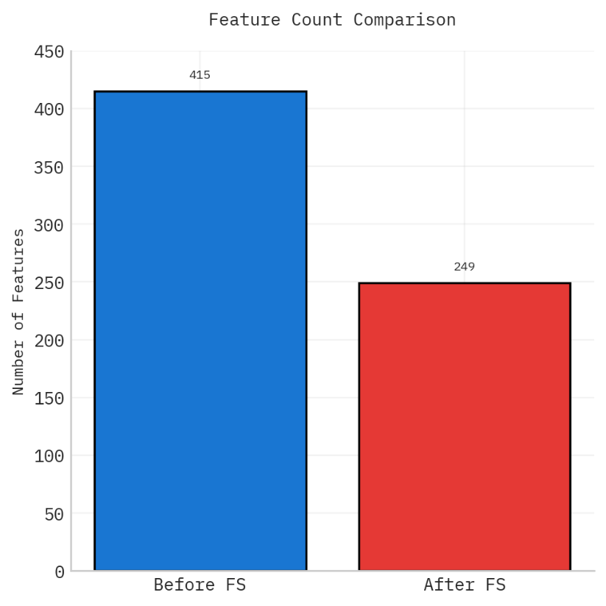
Fig. 14. Before FS and After FS of AndroMD data
Fig. 14 represents the FS results of the proposed model before FS and after FS on the AndroMD dataset. The figure demonstrate the better performance of the proposed model by reducing the feature subset significantly.
Fig. 15 indicates the confusion matrices formed by the IATDL-IAMD model on the Train/Test using AndroMDdata with FS. The outcome indicates that the IATDL-IAMD methodology has effective recognition of each class.
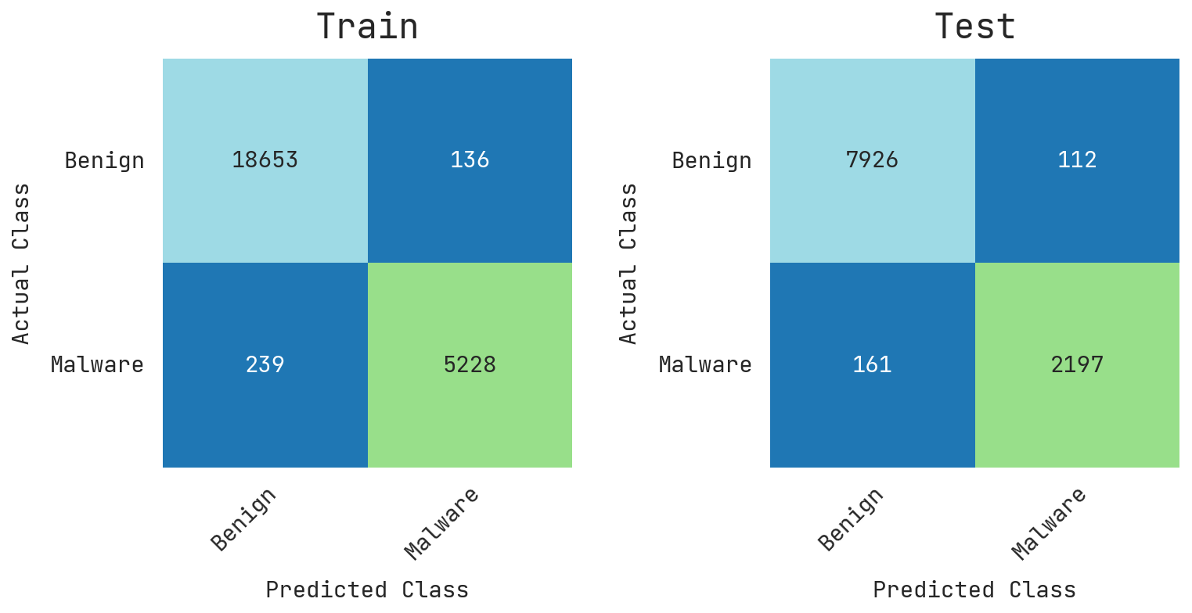
Fig. 15. Confusion matrices of the IATDL-IAMD method with FS under AndroMDdata
Table 6 signifies the training and testing results of the IATDL-IAMD methodology using AndroMD data with FS, with numerous metrics. In training set, the proposed IATDL-IAMD system offers an average value with $accur_{y}$ of 98.45%, $preci_{n}$ of 98.10%, $sen{si}_{y}$ of 97.45%, $spe{ci}_{y}$ of 97.45%, and $G_{measure}$ of 95.55%, correspondingly. Similarly, in testing set, the proposed IATDL-IAMD system provides an average outcomes with $accur_{y}$ of 97.37%, $preci_{n}$ of 96.58%, $sen{si}_{y}$ of 95.89%, $spe{ci}_{y}$ of 95.89%, and $G_{measure}$ of 92.47%, correspondingly.
Table 6 Train/Test set results of the IATDL-IAMD method on AndroMD data with FS
Metrics | Training Set | Testing Set
Accuracy | 98.45 | 97.37
Precision | 98.10 | 96.58
Sensitivity | 97.45 | 95.89
Specificity | 97.45 | 95.89
G-Measure | 95.55 | 92.47

Fig. 16 exemplifies the PR/ROC curves of IATDL-IAMD model on training and testing stages with AndroMD data. Figs. 16a and 16c illustrates the PR curve of the IATDL-IAMD methodology. The solution specified that the IATDL-IAMD model give greater PR values. Furthermore, it is evident that the IATDL-IAMD model can accomplishes superior PR values on every class labels. Eventually, Figs. 16b and 16d demonstrate the ROC analysis of the IATDL-IAMD methodology. The figure depicts that the IATDL-IAMD model reaches amplified ROC values. Furthermore, it is noticeable that the IATDL-IAMD approach can increase greater ROC values on every class labels.
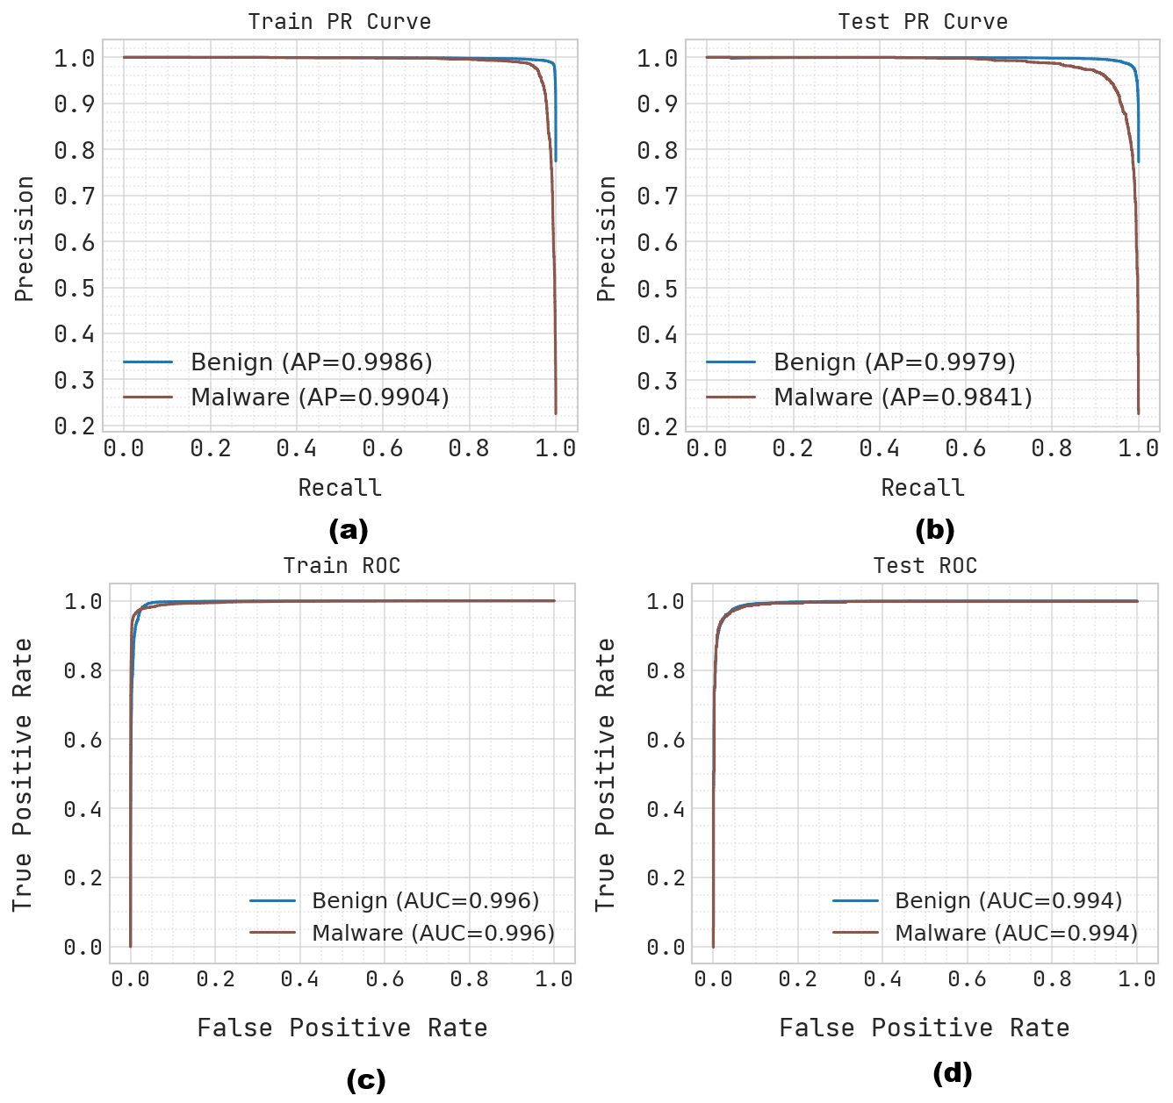
Fig. 16. PR/ROC curve of the IATDL-IAMD method with (a, c) Training and (b, d) Testing phases on the applied AndroMD dataset
Fig. 17 compares the training performance of dual approaches through epochs. It shows training and validation accuracy together with corresponding loss curves to calculate learning behavior. This trend illustrates the model's improvement over time and its capability to generalize effectively on unseen data. The comparison emphasizes changes in convergence speed, steadiness, and overall predictive outcomes between the dual techniques.
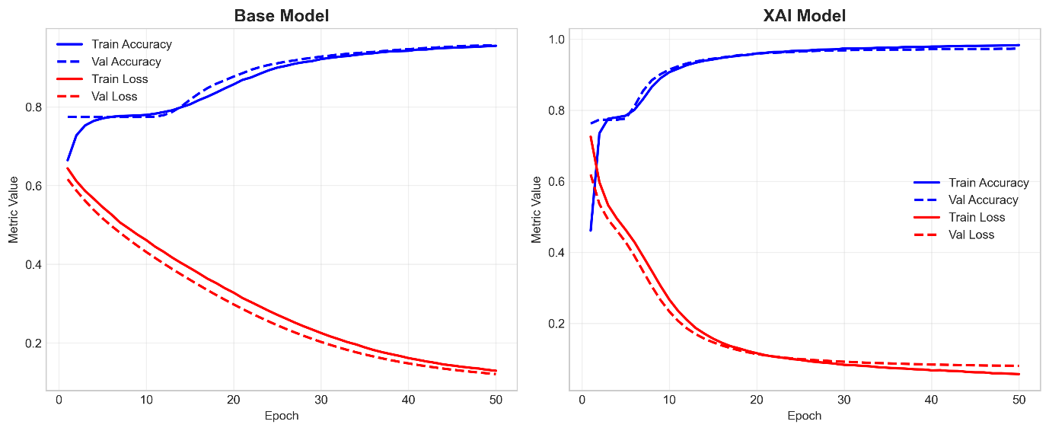
Fig. 17. Accuracy and Loss Graphs of Base and XAI models on AndroMD dataset
To exhibit the greater performance of the IATDL-IAMD approach on the AndroMD dataset, a brief comparison analysis is displayed in Table 7 and Fig. 18 [27-29]. The solution exhibited that the DT, KNN, and CNN approaches show lower classification outcomes. Additionally, the MsDroid, MalDetGCN, and AMD-BFGCN models attain closer solutions. Furthermore, the IATDL-IAMD (Baseline Model) technique has gained considerable outcomes with $accur_{y}$ of 95.78%, $preci_{n}$ of 93.86%, $sen{si}_{y}$ of 94.08%, $spe{ci}_{y}$ of 94.08%, and $G_{measure}$ of 87.94% whereas the IATDL-IAMD (Baseline + XAI Model) has accomplished superior performance with $accur_{y}$ of 98.45%, $preci_{n}$ of 98.10%, $sen{si}_{y}$ of 97.45%, and $spe{ci}_{y}$ of 97.45%, $G_{measure}$ of 95.55%.
Table 7 Comparative result of the IATDL-IAMD system with existing approaches under AndroMD dataset
Model | $Acc{ur}_{y}$ | $Pre{ci}_{n}$ | $$Sen{si}_{y}$$ | $$Spe{ci}_{y}$$ | $$G_{Measure}$$
CNN | 96.00 | 95.00 | 97.00 | 96.00 | 83.82
MsDroid | 97.00 | 97.00 | 97.20 | 97.10 | 84.20
MalDetGCN | 97.80 | 97.20 | 97.80 | 95.10 | 81.66
Decision Tree | 92.00 | 92.01 | 92.10 | 92.50 | 86.02
K-Nearest Neighbor | 93.00 | 93.11 | 92.92 | 94.95 | 86.57
AMD-BFGCN | 98.01 | 96.89 | 95.05 | 95.47 | 81.21
IATDL-IAMD (Baseline Model) | 95.78 | 93.86 | 94.08 | 94.08 | 87.94
IATDL-IAMD (Baseline +XAI Model) | 98.45 | 98.10 | 97.45 | 97.45 | 95.55
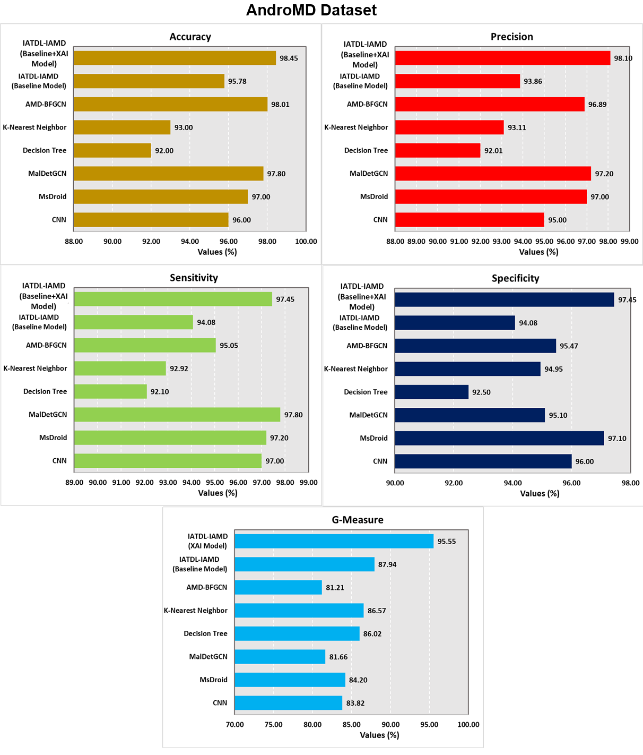
Fig. 18. Comparison outcomes of the IATDL-IAMD approach under AndroMD dataset
Based on the comprehensive analysis, the results clearly shows that the IATDL-IAMD methodology outperforms the competing models in terms of overall performance.
5. Conclusion and Future Work
This paper has introduced an IATDL-IAMD algorithm to understand strong detection performance while improving transparency and trustworthiness in Android malware classification. Primarily, the data pre-processing has been performed, including data cleaning, missing value handling, label encoding, feature scaling, and data splitting to create optimized feature matrices and label vectors. A transformer-based classifier with dense feature embedding and MHA can first be established as a baseline to proficiently capture complex relationships among high-dimensional malware features. To address the interpretability limitations of the DL system and feature subset selection process, SHAP-based explainability can be combined with the proposed framework. This integration allows both global and local interpretation of predictions by quantifying feature contributions and mapping malware behavioral patterns. This combination of deep representation learning and interpretability-aware feature importance analysis has been proven to improve trust and practical usability of the recognition system. The proposed IATDL-IAMD system is experimentally validated by exploiting two benchmark datasets, such as CICMalDroid 2020 and AndroMD. Experimental outcomes validate the superiority of the proposed methodology under numerous performance metrics, confirming its efficiency in realizing robust and interpretable Android malware detection. In future work, the model can be tested on more recent and real-time Android malware datasets to improve its practical use in real-world scenarios. It can also be improved by using lightweight transformer models to reduce computational cost, making it more suitable for mobile and edge devices. Further, adversarial training techniques can be included to increase robustness against emerging malware attacks. The explainability aspect can also be enhanced by integrating SHAP with other interpretability techniques to offer more stable and reliable feature-level insights for security analysis.
Data Availability Statement: The data that support the findings of this study are openly available at https://www.unb.ca/cic/datasets/maldroid-2020.html and https://data.mendeley.com/datasets/pwyj5b3khp/1, reference number [22, 23].
References
- Joomye, A., Ling, M.H. and Yau, K.L.A., 2025. A brief survey of deep learning methods for android Malware detection. International Journal of System Assurance Engineering and Management, 16(2), pp.711-733.
- Kharnotia, S., Arora, B. and Kour, R., 2026. Feature-Driven Static Analysis for Learning-Based Android Malware Detection: A Review. ICT Express.
- Song, Y., Zhang, D., Wang, J., Wang, Y., Wang, Y. and Ding, P., 2025. Application of deep learning in malware detection: a review. Journal of Big Data, 12(1), p.99.
- Hosahalli Dayananda, P. and Chen, Z., 2026. Re-Evaluating Android Malware Detection: Tabular Features, Vision Models, and Ensembles. Electronics, 15(3), p.544.
- Sharma, S., Ahlawat, P. and Khanna, K., 2024. DeepMDFC: a deep learning based android malware detection and family classification method. Security and Privacy, 7(2), p.e347.
- Guerra-Manzanares, A., 2024. Machine learning for android malware detection: mission accomplished? a comprehensive review of open challenges and future perspectives. Computers & Security, 138, p.103654.
- Liu, G., Caragea, D., Ou, X. and Roy, S., 2025. Benchmarking android malware detection: traditional vs. deep learning models. arXiv preprint arXiv:2502.15041.
- Muzaffar, A., Ragab Hassen, H., Zantout, H. and Lones, M.A., 2026. Reassessing feature-based Android malware detection in a contemporary context. PloS one, 21(1), p.e0341013.
- Taheri, R., Shojafar, M., Arabikhan, F. and Gegov, A., 2024. Unveiling vulnerabilities in deep learning-based malware detection: Differential privacy driven adversarial attacks. Computers & Security, 146, p.104035.
- Sharma, M. and Kaul, A., 2024. A review of detecting malware in android devices based on machine learning techniques. Expert Systems, 41(1), p.e13482.
- Nannan, X., Linyang, M., Yangfan, W. and Yubo, M., 2025. Andro-BCFL: Blockchain and federated learning based Android malware detection. Computers and Electrical Engineering, 122, p.109948.
- Tang, J., Zhou, S., Peng, T. and Tian, W., 2026. Dapadv: Differentiated adversarial perturbation generation method in problem space for android malware detection. Computers & Security, p.104845.
- Chakif, K., Nawshin, F. and Unal, D., 2026. Robust Android Malware Detection Against Obfuscation and Adversarial Attacks Using RGB Markov Images and Deep Ensemble Learning. Knowledge-Based Systems, p.115376.
- Nasser, A.R., Hasan, A.M. and Humaidi, A.J., 2024. DL-AMDet: Deep learning-based malware detector for android. Intelligent Systems with Applications, 21, p.200318.
- Tian, D., Niu, Z., Leng, T., Jiang, J., Chen, P., Hu, C., Yuan, C. and Deng, R., 2026. A novel graph neural network-based approach for android malware detection. Applied Soft Computing, p.114689.
- Kauser. Sk, H. and Anu. V, M., 2025. Hybrid deep learning model for accurate and efficient android malware detection using DBN-GRU. PloS one, 20(5), p.e0310230.
- Maray, M., Maashi, M., Alshahrani, H.M., Aljameel, S.S., Abdelbagi, S. and Salama, A.S., 2024. Intelligent pattern recognition using equilibrium optimizer with deep learning model for android malware detection. IEEE Access, 12, pp.24516-24524.
- Rashid, M.U., Qureshi, S., Abid, A., Alqahtany, S.S., Alqazzaz, A., ul Hassan, M., Al Reshan, M.S. and Shaikh, A., 2025. Hybrid android malware detection and classification using deep neural networks. International Journal of Computational Intelligence Systems, 18(1), p.52.
- Feng, J., Shen, L., Chen, Z., Lei, Y. and Li, H., 2025. HGDetector: A hybrid Android malware detection method using network traffic and Function call graph. Alexandria Engineering Journal, 114, pp.30-45.
- Tang, J., Tian, X., Peng, T., Lu, J., Wang, H. and Li, R., 2026. HHGDroid: Hybrid Heterogeneous Graph-Based Android Malware Detection via Multi-Evidence Similarity Fusion. Expert Systems with Applications, p.131528.
- Cam, N.T., Huy, T.M. and Tin, N.T., 2026. Malware classification using deep neural networks with Deep Q-Learning and eXplainable artificial intelligence. Engineering Applications of Artificial Intelligence, 166, p.113622.
- https://www.unb.ca/cic/datasets/maldroid-2020.html
- https://data.mendeley.com/datasets/pwyj5b3khp/1
- Kurniasari, D., Humairosi, L., Warsono, W. and Notiragayu, N., 2025. Implementation of Random Forest Method for Customer Churn Classification. JSI: Jurnal Sistem Informasi (E-Journal), 17(1), pp.187-202.
- Harshdeep, K., Sumalatha, K. and Mathur, R., 2025. DeepTransIDS: Transformer-based deep learning model for detecting DDoS attacks on 5G NIDD. Results in Engineering, 26, p.104826.
- Chen, X., Liu, M., Wang, Z. and Wang, Y., 2024. Explainable deep learning-based feature selection and intrusion detection method on the internet of things. Sensors, 24(16), p.5223.
- Aldhafferi, N., 2024. Android malware detection using support vector regression for dynamic feature analysis. Information, 15(10), p.658.
- Xu, Q., Zhao, D., Yang, S., Xu, L. and Li, X., 2023. Android malware detection based on behavioral-level features with graph convolutional networks. Electronics, 12(23), p.4817.
- Babbar, H., Rani, S., Sah, D.K., AlQahtani, S.A. and Kashif Bashir, A., 2023. Detection of Android malware in the Internet of Things through the K-nearest neighbor algorithm. Sensors, 23(16), p.7256.

